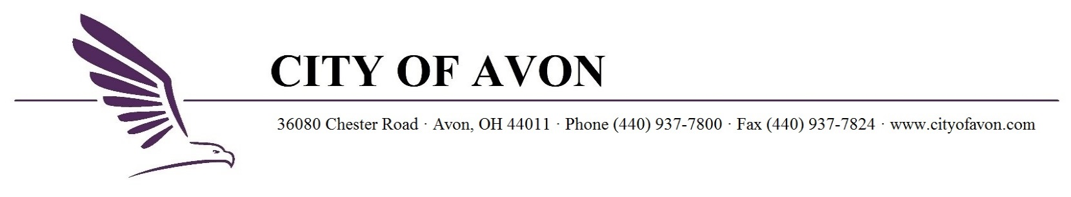

AVON CIVIL SERVICE COMMISSION
MEETING NOTICE

TO: AVON CIVIL SERVICE COMMISSION
Peter Kratt
Alan Wojciechowski
William Greaney

DATE: Monday, April 6th, 2026

TIME: 10:00 AM

PLACE: Avon City Hall – Council Chambers

AGENDA:
Approve Minutes of March 2, 2026, Meeting
Certify Updated Clerical Eligibility List
Certify Updated Labor Eligibility List
Remove Names from Police Entry Eligibility List
Certify Updated Lateral Police Eligibility List
Certify Fire Lieutenant Promotional List

cc: John Gasior, Law Director
Duane Streator, Safety Director
Police Chief Fischbach
Fire Chief Swope
Diane Szlempa, Secretary

